UNIT-5
In programming, algorithm is a set of well defined instructions in sequence to solve the problem.

Qualities of a good algorithm
- Input and output should be defined precisely.
- Each steps in algorithm should be clear and unambiguous.
- Algorithm should be most effective among many different ways to solve a problem.
- An algorithm shouldn't have computer code. Instead, the algorithm should be written in such a way that, it can be used in similar programming languages.

Write an algorithm to find all roots of a quadratic equation ax²+bx+c=0.
Step 1: Start
Step 2: Declare variables a, b, c, D, r1, r2, rp and ip;
Step 3: Calculate discriminant
D←b2-4ac
Step 4: If D≥0
r1←(-b+√D)/2a
r2←(-b-√D)/2a
Display r1 and r2 as roots.
Else
Calculate real part and imaginary part
rp←b/2a
ip←√(-D)/2a
Display rp+i(ip) and rp-i(ip) as roots
Step 5: Stop

Write an algorithm to check whether a number entered by user is prime or not.
Step 1: Start
Step 2: Declare variables n,i,flag.
Step 3: Initialize variables
flag←1
i←2
Step 4: Read n from user.
Step 5: Repeat the steps until i<(n/2)
5.1 If remainder of n÷i equals 0
flag←0
Go to step 6
5.2 i←i+1
Step 6: If flag=0
Display n is not prime
else
Display n is prime
Step 7: Stop

Write an algorithm to find the factorial of a number entered by user.
Step 1: Start
Step 2: Declare variables n,factorial and i.
Step 3: Initialize variables
factorial←1
i←1
Step 4: Read value of n
Step 5: Repeat the steps until i=n
5.1: factorial←factorial*i
5.2: i←i+1
Step 6: Display factorial
Step 7: Stop

Write an algorithm to add two numbers entered by user.
Step 1: Start
Step 2: Declare variables num1, num2 and sum.
Step 3: Read values num1 and num2.
Step 4: Add num1 and num2 and assign the result to sum.
sum←num1+num2
Step 5: Display sum
Step 6: Stop

Write an algorithm to find the largest among three different numbers entered by user.
Step 1: Start
Step 2: Declare variables a,b and c.
Step 3: Read variables a,b and c.
Step 4: If a>b
If a>c
Display a is the largest number.
Else
Display c is the largest number.
Else
If b>c
Display b is the largest number.
Else
Display c is the greatest number.
Step 5: Stop

Write an algorithm for finding minimum and maximum numbers of a given set

step1: start
step2: Declare the variables a[], n, i, min, max
step3: read n value from the user and enter values in the array.
step4: initialize min=a[0] and max=a[0]
step5: for i=0 to n-1
if(min>a[i])
min=a[i];
step6:for i=0 to n-1
if(max<a[i])
max=a[i];
step7: display min as the smallest element
step8: display max as the largest element
step9: stop

What is Search?
Search is a process of finding a value in a list of values. In other words, searching is the process of locating given value position in a list of values.

Linear Search Algorithm (Sequential Search Algorithm)
Linear search algorithm finds given element in a list of elements with O(n) time complexity where n is total number of elements in the list. This search process starts comparing of search element with the first element in the list. If both are matching then results with element found otherwise search element is compared with next element in the list. If both are matched, then the result is "element found". Otherwise, repeat the same with the next element in the list until search element is compared with last element in the list, if that last element also doesn't match, then the result is "Element not found in the list". That means, the search element is compared with element by element in the list.
Linear search is implemented using following steps...
Step 1 - Read the search element from the user
Step 2 - Compare, the search element with the first element in the list.
Step 3 - If both are matching, then display "Given element found!!!" and terminate the function
Step 4 - If both are not matching, then compare search element with the next element in the list.
Step 5 - Repeat steps 3 and 4 until the search element is compared with the last element in the list.
Step 6 - If the last element in the list is also doesn't match, then display "Element not found!!!" and terminate the function.

Example
Consider the following list of element and search element...
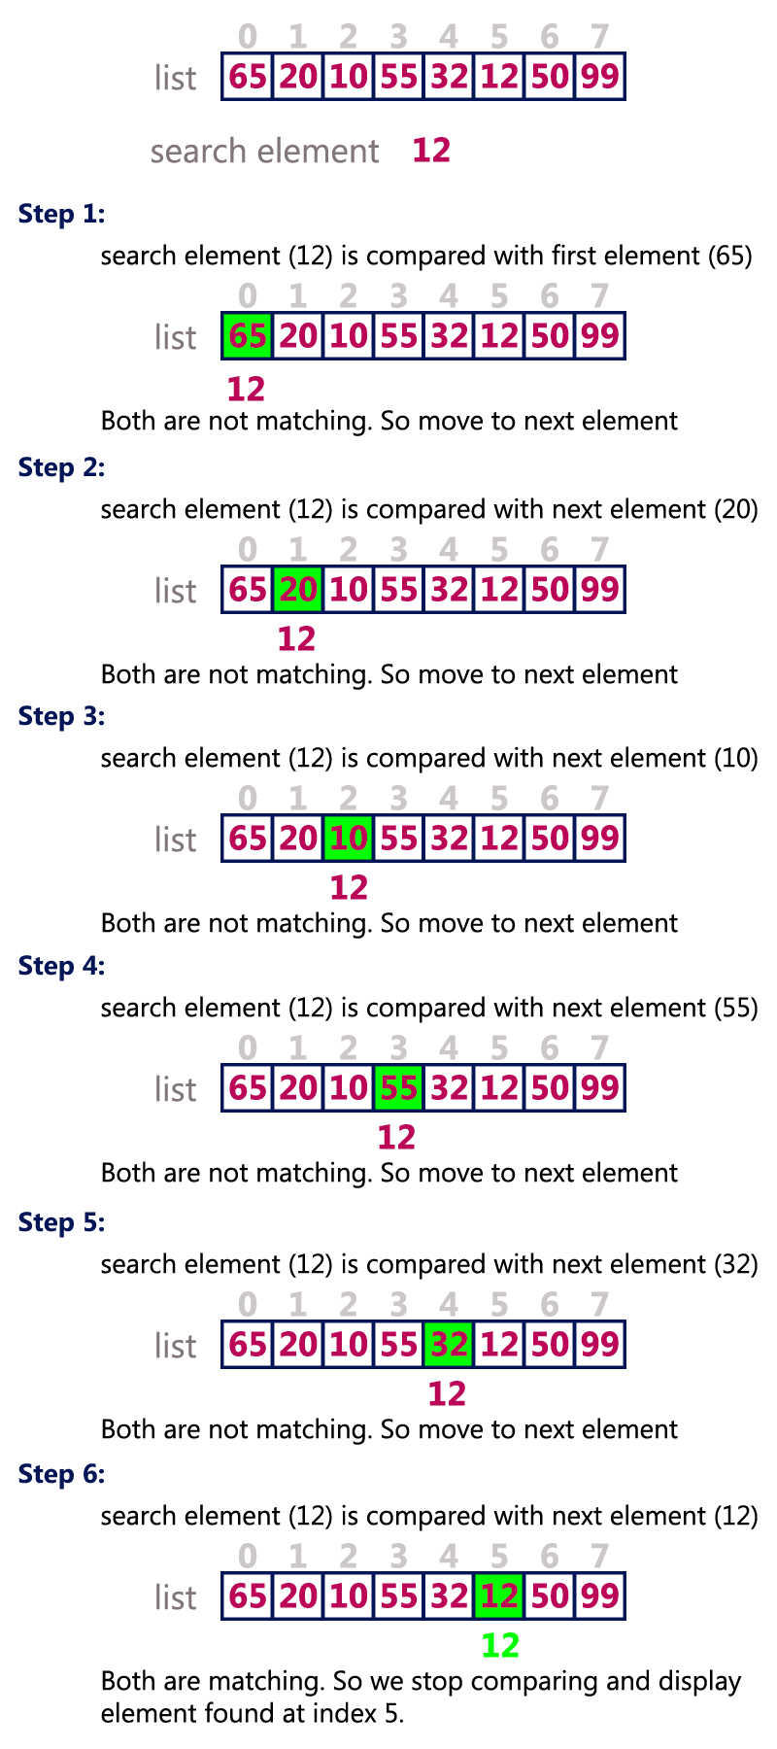
program for linear search:

void main()
{
int a[50],n,i,e;
clrscr();
printf("enter no of elements:\n");
scanf("%d",&n);
printf("enter elements into the list:\n");
for(i=0;i<n;i++)
{
scanf("%d",&a[i]);
}
printf("enter search element:\n");
scanf("%d",&e);
for(i=0;i<n;i++)
{
if(e==a[i])
{
printf("element found");
getch();
exit();
}
}
printf("element not found");
getch();
}

Binary Search Algorithm
Binary search algorithm finds given element in a list of elements with O(log n) time complexity where n is total number of elements in the list. The binary search algorithm can be used with only sorted list of element. That means, binary search can be used only with lkist of element which are already arraged in a order. The binary search can not be used for list of element which are in random order. This search process starts comparing of the search element with the middle element in the list. If both are matched, then the result is "element found". Otherwise, we check whether the search element is smaller or larger than the middle element in the list. If the search element is smaller, then we repeat the same process for left sublist of the middle element. If the search element is larger, then we repeat the same process for right sublist of the middle element. We repeat this process until we find the search element in the list or until we left with a sublist of only one element. And if that element also doesn't match with the search element, then the result is "Element not found in the list".
Binary search is implemented using following steps...
Step 1 - Read the search element from the user
Step 2 - Find the middle element in the sorted list.
Step 3 - Compare, the search element with the middle element in the sorted list.
Step 4 - If both are matching, then display "Given element found!!!" and terminate the function.
Step 5 - If both are not matching, then check whether the search element is smaller or larger than middle element.
Step 6 - If the search element is smaller than middle element, then repeat steps 2, 3, 4 and 5 for the left sublist of the middle element.
Step 7 - If the search element is larger than middle element, then repeat steps 2, 3, 4 and 5 for the right sublist of the middle element.
Step 8 - Repeat the same process until we find the search element in the list or until sublist contains only one element.
Step 9 - If that element also doesn't match with the search element, then display "Element not found in the list!!!" and terminate the function.

Example
Consider the following list of element and search element...
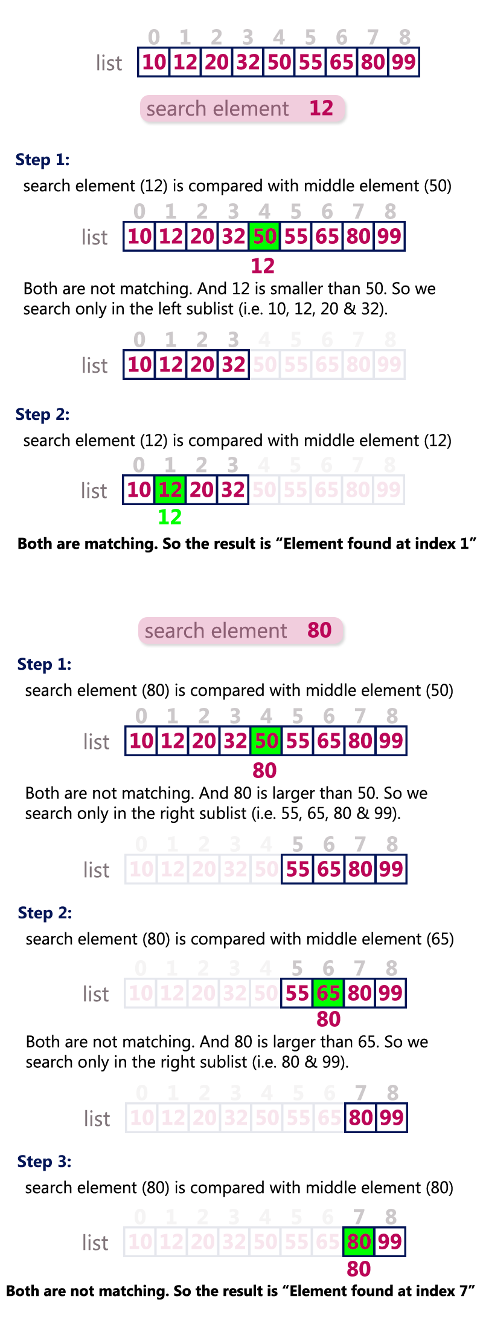
Program for binary search:

#include<stdio.h>
#include<conio.h>

void main()
{
int a[50],n,i,l,u,mid,se;
clrscr();
printf("enter no of elements:\n");
scanf("%d",&n);
printf("enter elements in to the list:\n");
for(i=0;i<n;i++)
{
scanf("%d",&a[i]);
}
printf("enter search element:\n");
scanf("%d",&se);
l=0;
u=n-1;
mid=(l+u)/2;
while(l<=u)
{
if(se==a[mid])
{
printf("element found");
break;
}
if(se>a[mid])
l=mid+1;
else
u=mid-1;
mid=(l+u)/2;
}
if(l>u)
printf("element not found");
getch();
}

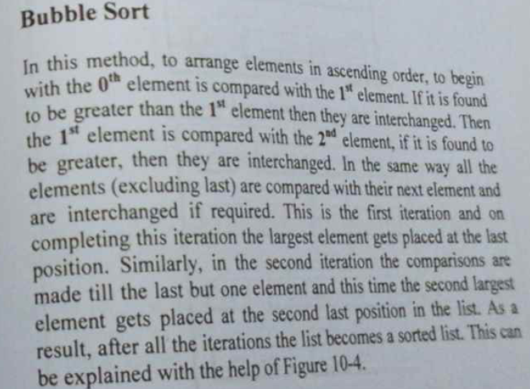

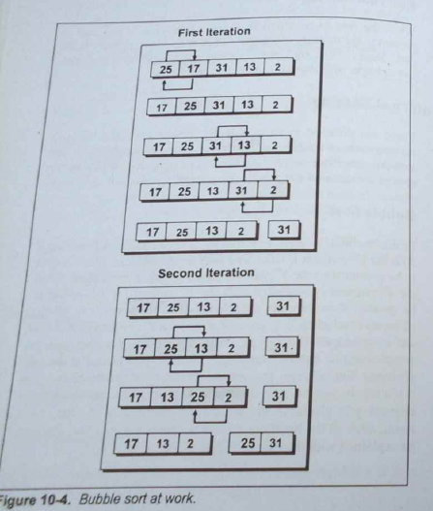
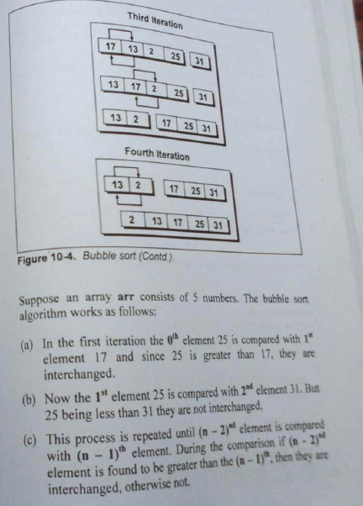
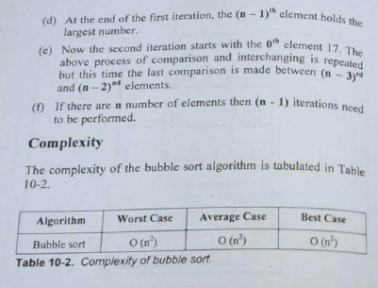

Program for bubble sort:

#include<stdio.h>
#include<conio.h>

void main()
{
int a[50],n,i,j,temp;
clrscr();
printf("enter no of elements:\n");
scanf("%d",&n);
printf("enter elements in to the list:\n");
for(i=0;i<n;i++)
{
scanf("%d",&a[i]);
}

for(i=0;i<n-1;i++)
{
for(j=0;j<n-1;j++)
{
if(a[j]>a[j+1])
{
temp=a[j];
a[j]=a[j+1];
a[j+1]=temp;
}
}
}
printf("the sorted list:\n");
for(i=0;i<n;i++)
{
printf("%d\t",a[i]);
}
getch();
}

Insertion Sort Algorithm
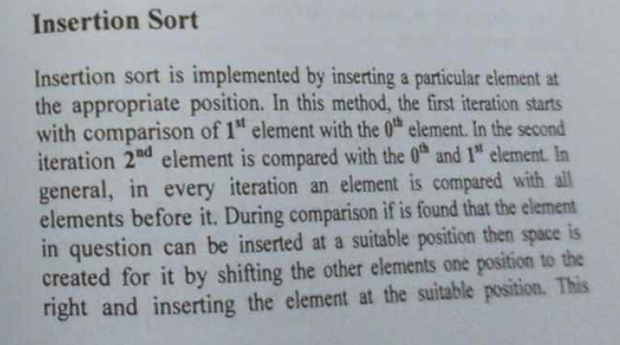
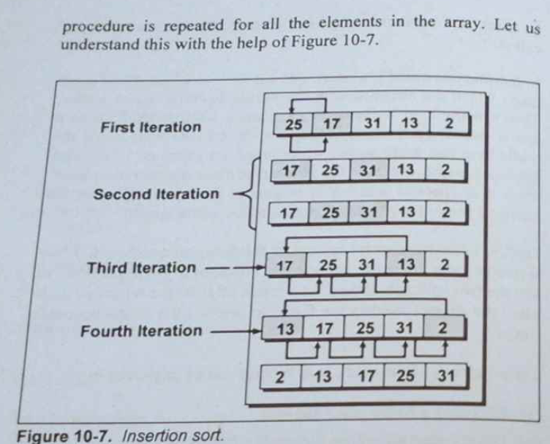
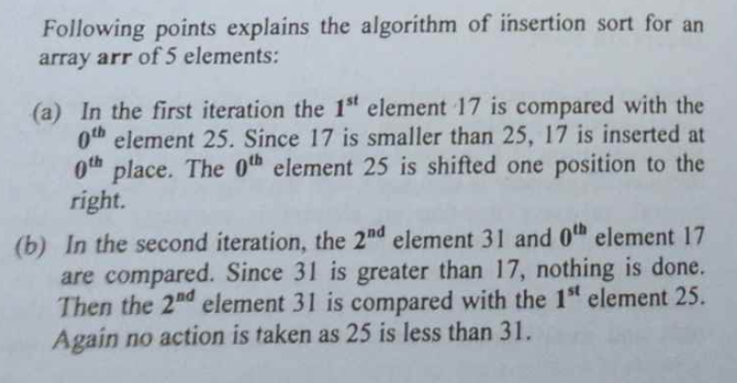
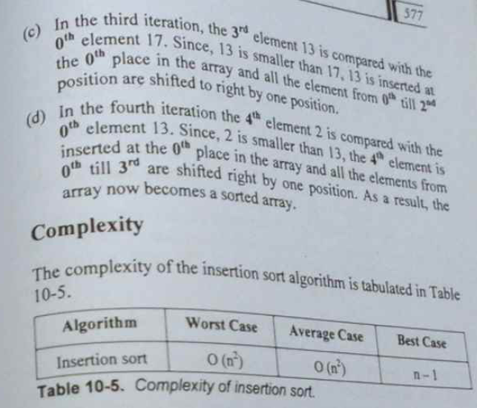
Sorting is the process of arranging a list of elements in a particular order (Ascending or Descending).
Insertion sort algorithm arranges a list of elements in a particular order. In insertion sort algorithm, every iteration moves an element from unsorted portion to sorted portion until all the elements are sorted in the list.
Step by Step Process
The insertion sort algorithm is performed using following steps...
Step 1 - Asume that first element in the list is in sorted portion of the list and remaining all elements are in unsorted portion.
Step 2: Consider first element from the unsorted list and insert that element into the sorted list in order specified.
Step 3: Repeat the above process until all the elements from the unsorted list are moved into the sorted list.
Example
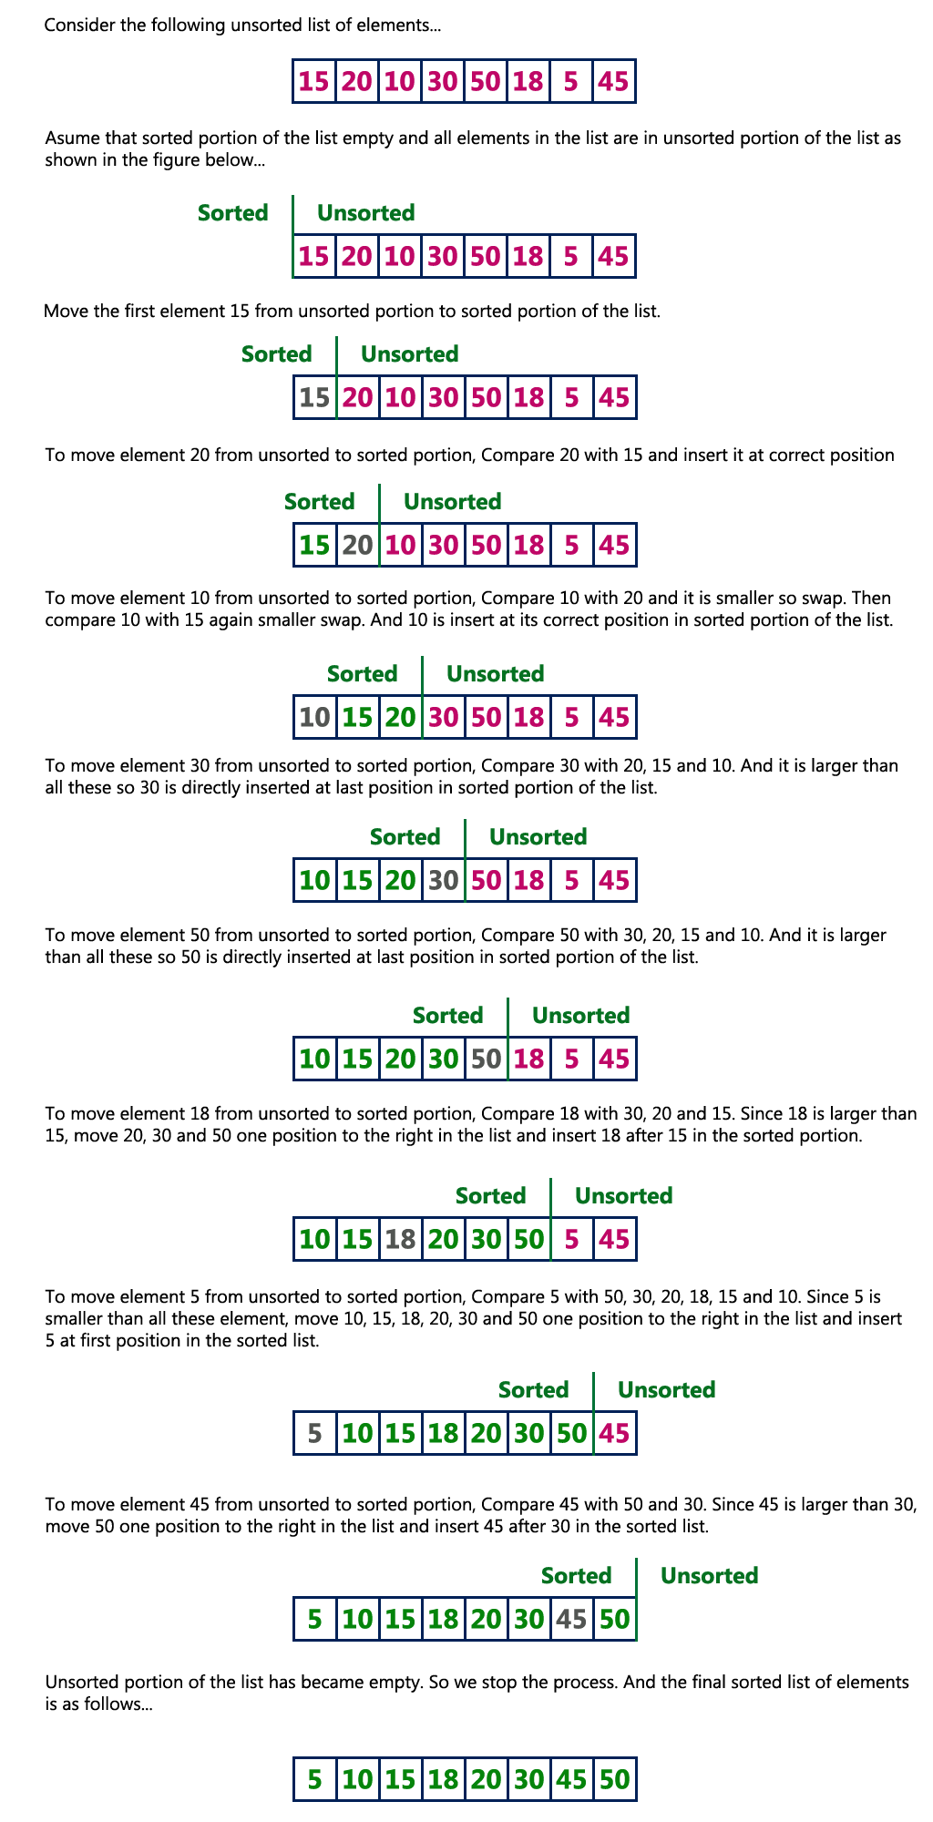
Complexity of the Insertion Sort Algorithm
To sort a unsorted list with 'n' number of elements we need to make (1+2+3+......+n-1) = (n (n-1))/2 number of comparisions in the worst case. If the list already sorted, then it requires 'n' number of comparisions.
Worst Case: O(n²)
Best Case : n-1
Average Case : O(n²)
Program for insertion sort:

#include<stdio.h>
#include<conio.h>

void main()
{
int a[50],n,i,j,k,temp;
clrscr();
printf("enter no of elements:\n");
scanf("%d",&n);
printf("enter elements in to the list:\n");
for(i=0;i<n;i++)
{
scanf("%d",&a[i]);
}

for(i=1;i<n;i++)
{
for(j=0;j<i;j++)
{
if(a[j]>a[i])
{
temp=a[j];
a[j]=a[i];
for(k=i;k>j;k--)
a[k]=a[k-1];
a[k+1]=temp;
}
}
}

printf("the sorted list:\n");
for(i=0;i<n;i++)
{
printf("%d\t",a[i]);
}
getch();
}

Selection Sort Algorithm
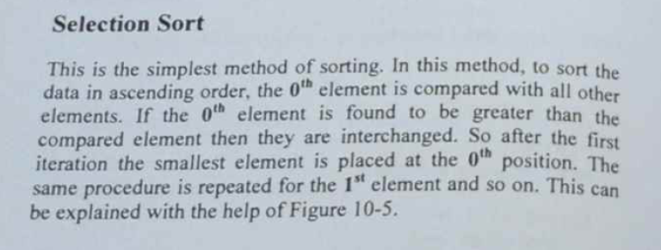
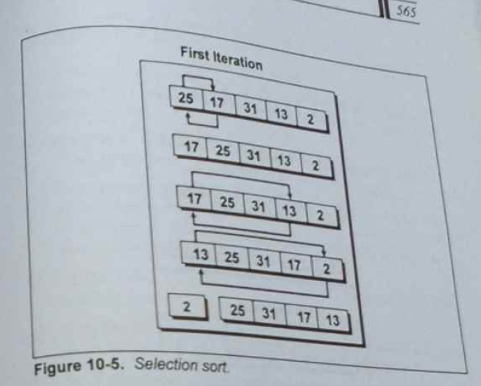
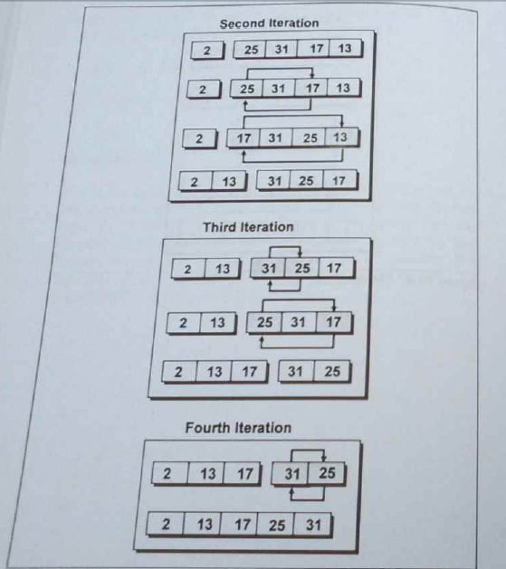
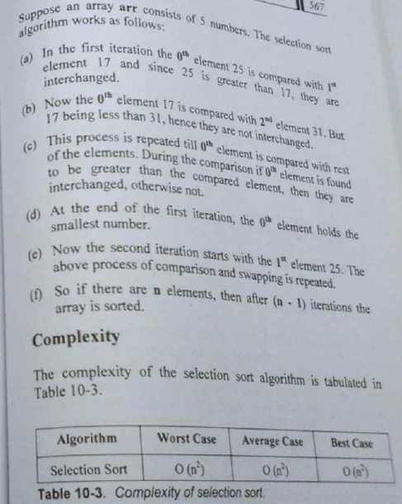
Selection Sort algorithm is used to arrange a list of elements in a particular order (Ascending or Descending). In selection sort, the first element in the list is selected and it is compared repeatedly with remaining all the elements in the list. If any element is smaller than the selected element (for Ascending order), then both are swapped. Then we select the element at second position in the list and it is compared with remaining all elements in the list. If any element is smaller than the selected element, then both are swapped. This procedure is repeated till the entire list is sorted.
Step by Step Process
The selection sort algorithm is performed using following steps...
Step 1 - Select the first element of the list (i.e., Element at first position in the list).
Step 2: Compare the selected element with all other elements in the list.
Step 3: For every comparision, if any element is smaller than selected element (for Ascending order), then these two are swapped.
Step 4: Repeat the same procedure with next position in the list till the entire list is sorted.
Example
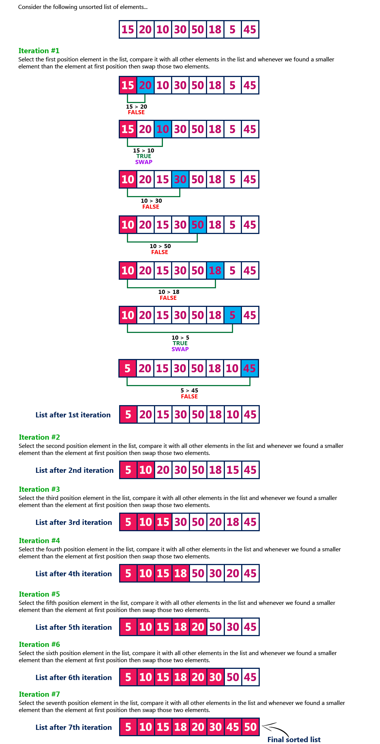
Complexity of the Selection Sort Algorithm
To sort a unsorted list with 'n' number of elements we need to make ((n-1)+(n-2)+(n-3)+......+1) = (n (n-1))/2 number of comparisions in the worst case. If the list already sorted, then it requires 'n' number of comparisions.
Worst Case: O(n²)
Best Case : O(n²)
Average Case : O(n²)
Program for selection sort:
#include<stdio.h>
#include<conio.h>

void main()
{
int a[50],n,i,j,temp;
clrscr();
printf("enter no of elements:\n");
scanf("%d",&n);
printf("enter elements in to the list:\n");
for(i=0;i<n;i++)
{
scanf("%d",&a[i]);
}

for(i=0;i<n-1;i++)
{
for(j=i+1; j<n;j++)
{
if(a[i]>a[j])
{
temp=a[i];
a[i]=a[j];
a[j]=temp;
}
}
}
printf("the sorted list:\n");
for(i=0;i<n;i++)
{
printf("%d\t",a[i]);
}
getch();
}

Performance Analysis

What is Performance Analysis of an algorithm?
If we want to go from city "A" to city "B", there can be many ways of doing this. We can go by flight, by bus, by train and also by bicycle. Depending on the availability and convenience, we choose the one which suits us. Similarly, in computer science there are multiple algorithms to solve a problem. When we have more than one algorithm to solve a problem, we need to select the best one. Performance analysis helps us to select the best algorithm from multiple
algorithms to solve a problem.
When there are multiple alternative algorithms to solve a problem, we analyse them and pick the one which is best suitable for our requirements. Formal definition is as follows...
Performance of an algorithm is a process of making evaluative judgement about algorithms.
It can also be defined as follows...
Performance of an algorithm means predicting the resources which are required to an algorithm to perform its task.
That means when we have multiple algorithms to solve a problem, we need to select a suitable algorithm
to solve that problem. We compare algorithms with each other which are solving same problem, to select the best algorithm. To compare algorithms, we use a set of parameters or set of elements like memory required by that algorithm, execution speed of that algorithm, easy to understand, easy to implement, etc.,
Generally, the performance of an algorithm depends on the following elements...
- Whether that algorithm is providing the exact solution for the problem?
- Whether it is easy to understand?
- Whether it is easy to implement?
- How much space (memory) it requires to solve the problem?
- How much time it takes to solve the problem? Etc.,
When we want to analyse an algorithm, we consider only the space and time required by that particular algorithm and we ignore all the remaining elements.Based on this information, performance analysis of an algorithm can also be defined as follows...
Performance analysis of an algorithm is the process of calculating space and time required by that algorithm.
Performance analysis of an algorithm is performed by using the following measures...
- Space required to complete the task of that algorithm (Space Complexity). It includes program space and data space
- Time required to complete the task of that algorithm (Time Complexity)

What is Space complexity?
When we design an algorithm to solve a problem, it needs some computer memory to complete its execution. For any algorithm, memory is required for the following purposes...
- To store program instructions.
- To store constant values.
- To store variable values.
- And for few other things like funcion calls, jumping statements etc,.
Space complexity of an algorithm can be defined as follows...
Total amount of computer memory required by an algorithm to complete its execution is called as space complexity of that algorithm.
Generally, when a program is under execution it uses the computer memory for THREE reasons. They are as follows...
- Instruction Space: It is the amount of memory used to store compiled version of instructions.
- Environmental Stack: It is the amount of memory used to store information of partially executed functions at the time of function call.
- Data Space: It is the amount of memory used to store all the variables and constants.
Note - When we want to perform analysis of an algorithm based on its Space complexity, we consider only Data Space and ignore Instruction Space as well as Environmental Stack. That means we calculate only the memory required to store Variables, Constants, Structures, etc.,
To calculate the space complexity, we must know the memory required to store different datatype values (according to the compiler). For example, the C Programming Language compiler requires the following...
- 2 bytes to store Integer value.
- 4 bytes to store Floating Point value.
- 1 byte to store Character value.
- 6 (OR) 8 bytes to store double value.
Consider the following piece of code...

Example 1
int square(int a)
{
return a*a;
}
In the above piece of code, it requires 2 bytes of memory to store variable 'a' and another 2 bytes of memory is used for return value.
That means, totally it requires 4 bytes of memory to complete its execution. And this 4 bytes of memory is fixed for any input value of 'a'. This space complexity is said to be Constant Space Complexity.
If any algorithm requires a fixed amount of space for all input values then that space complexity is said to be Constant Space Complexity.
Consider the following piece of code...

Example 2
int sum(int A[ ], int n)
{
int sum = 0, i;
for(i = 0; i < n; i++)
sum = sum + A[i];
return sum;
}
In the above piece of code it requires 'n*2' bytes of memory to store array variable 'a[ ]' 2 bytes of memory for integer parameter 'n' 4 bytes of memory for local integer variables 'sum' and 'i' (2 bytes each) 2 bytes of memory for return value.
That means, totally it requires '2n+8' bytes of memory to complete its execution. Here, the total amount of memory required depends on the value of 'n'. As 'n' value increases the space required also increases proportionately. This type of space complexity is said to be Linear Space Complexity.
If the amount of space required by an algorithm is increased with the increase of input value, then that space complexity is said to be Linear Space Complexity.

What is Time complexity?
Every algorithm requires some amount of computer time to execute its instruction to perform the task. This computer time required is called time complexity. Time complexity of an algorithm can be defined as follows...
The time complexity of an algorithm is the total amount of time required by an algorithm to complete its execution.
Generally, running time of an algorithm depends upon the following...
- Whether it is running on Single processor machine or Multi processor machine.
- Whether it is a 32 bit machine or 64 bit machine.
- Read and Write speed of the machine.
- The amount of time required by an algorithm to perform Arithmetic operations, logical operations, return value and assignment operations etc.,
- Input data
Note - When we calculate time complexity of an algorithm, we consider only input data and ignore the remaining things, as they are machine dependent. We check only, how our program is behaving for the different input values to perform all the operations like Arithmetic, Logical, Return value and Assignment etc.,

Calculating Time Complexity of an algorithm based on the system configuration is a very difficult task because, the configuration changes from one system to another system. To solve this problem, we must assume a model machine with specific configuration. So that, we can able to calculate generalized time complexity according to that model machine.
To calculate time complexity of an algorithm, we need to define a model machine. Let us assume a machine with following configuration...
- It is a Single processor machine
- It is a 32 bit Operating System machine
- It performs sequential execution
- It requires 1 unit of time for Arithmetic and Logical operations
- It requires 1 unit of time for Assignment and Return value
- It requires 1 unit of time for Read and Write operations
Now, we calculate the time complexity of following example code by using the above defined model machine...
Consider the following piece of code...

Example 1
int sum(int a, int b)
{
return a+b;
}
In above sample code, it requires 1 unit of time to calculate a+b and 1 unit of time to return the value. That means, totally it takes 2 units of time to complete its execution. And it does not change based on the input values of a and b. That means for all input values, it requires same amount of time i.e. 2 units.
If any program requires fixed amount of time for all input values then its time complexity is said to be Constant Time Complexity.
Consider the following piece of code...

Example 2
int sum(int A[], int n)
{
int sum = 0, i;
for(i = 0; i < n; i++)
sum = sum + A[i];
return sum;
}
For the above code, time complexity can be calculated as follows...
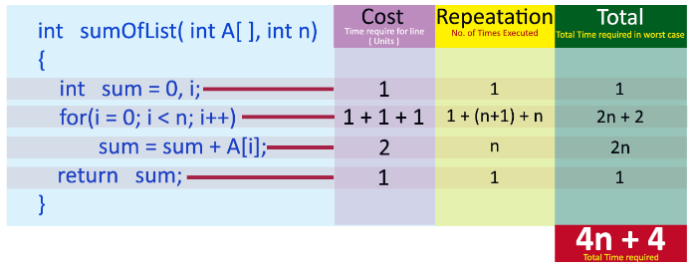
In above calculation
Cost is the amount of computer time required for a single operation in each line. Repeatation is the amount of computer time required by each operation for all its repeatations. Total is the amount of computer time required by each operation to execute. So above code requires '4n+4' Units of computer time to complete the task. Here the exact time is not fixed. And it changes based on the n value. If we increase the n value then the time required also increases linearly.
Totally it takes '4n+4' units of time to complete its execution and it is Linear Time Complexity.
If the amount of time required by an algorithm is increased with the increase of input value then that time complexity is said to be Linear Time Complexity.

Asymptotic Notations

What is Asymptotic Notation?
Whenever we want to perform analysis of an algorithm, we need to calculate the complexity of that algorithm. But when we calculate complexity of an algorithm it does not provide exact amount of resource required. So instead of taking exact amount of resource we represent that complexity in a general form (Notation) which produces the basic nature of that algorithm. We use that general form (Notation) for analysis process.
Asymptotic notation of an algorithm is a mathematical representation of its complexity.
Note - In asymptotic notation, when we want to represent the complexity of an algorithm, we use only the most significant terms in the complexity of that algorithm and ignore least significant terms in the complexity of that algorithm (Here complexity can be Space Complexity or Time Complexity).
For example, consider the following time complexities of two algorithms...
- Algorithm 1 : 5n² + 2n + 1
- Algorithm 2 : 10n² + 8n + 3
Generally, when we analyze an algorithm, we consider the time complexity for larger values of input data (i.e. 'n' value). In above two time complexities, for larger value of 'n' the term '2n + 1' in algorithm 1 has least significance than the term '5n²', and the term '8n + 3' in algorithm 2 has least significance than the term '10n²'.
Here, for larger value of 'n' the value of most significant terms ( 5n² and 10n² ) is very larger than the value of least significant terms ( 2n + 1 and 8n + 3 ). So for larger value of 'n' we ignore the least significant terms to represent overall time required by an algorithm. In asymptotic notation, we use only the most significant terms to represent the time complexity of an algorithm.
Majorly, we use THREE types of Asymptotic Notations and those are as follows...
- Big - Oh (O)
- Big - Omega (Ω)
- Big - Theta (Θ)

Big - Oh Notation (O)
Big - Oh notation is used to define the upper bound of an algorithm in terms of Time Complexity.
That means Big - Oh notation always indicates the maximum time required by an algorithm for all input values. That means Big - Oh notation describes the worst case of an algorithm time complexity.
Big - Oh Notation can be defined as follows...
Consider function f(n) as time complexity of an algorithm and g(n) is the most significant term.
If f(n) <= C g(n) for all n >= n₀, C > 0 and n₀ >= 1. Then we can represent f(n) as O(g(n)).
f(n) = O(g(n))
Consider the following graph drawn for the values of f(n) and C g(n) for input (n) value on X-Axis and time required is on Y-Axis
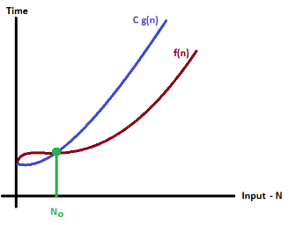
In above graph after a particular input value n₀, always C g(n) is greater than f(n) which indicates the algorithm's upper bound.
Example
Consider the following f(n) and g(n)...
f(n) = 3n + 2
g(n) = n
If we want to represent f(n) as O(g(n)) then it must satisfy f(n) <= C g(n) for all values of C > 0 and n₀>= 1
f(n) <= C g(n)
⇒3n + 2 <= C n
Above condition is always TRUE for all values of C = 4 and n >= 2.
By using Big - Oh notation we can represent the time complexity as follows...
3n + 2 = O(n)

Big - Omege Notation (Ω)
Big - Omega notation is used to define the lower bound of an algorithm in terms of Time Complexity.
That means Big - Omega notation always indicates the minimum time required by an algorithm for all input values. That means Big - Omega notation describes the best case of an algorithm time complexity.
Big - Omega Notation can be defined as follows...
Consider function f(n) as time complexity of an algorithm and g(n) is the most significant term.
If f(n) >= C g(n) for all n >= n₀, C > 0 and n₀ >= 1. Then we can represent f(n) as Ω(g(n)).
f(n) = Ω(g(n))
Consider the following graph drawn for the values of f(n) and C g(n) for input (n) value on X-Axis and time required is on Y-Axis
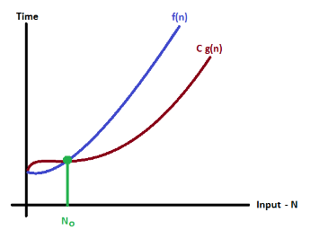
In above graph after a particular input value n₀, always C g(n) is less than f(n) which indicates the algorithm's lower bound.
Example
Consider the following f(n) and g(n)...
f(n) = 3n + 2
g(n) = n
If we want to represent f(n) as Ω(g(n)) then it must satisfy f(n) >= C g(n) for all values of C > 0 and n₀>= 1
f(n) >= C g(n)
⇒3n + 2 >= C n
Above condition is always TRUE for all values of C = 1 and n >= 1.
By using Big - Omega notation we can represent the time complexity as follows...
3n + 2 = Ω(n)

Big - Theta Notation (Θ)
Big - Theta notation is used to define the average bound of an algorithm in terms of Time Complexity.
That means Big - Theta notation always indicates the average time required by an algorithm for all input values. That means Big - Theta notation describes the average case of an algorithm time complexity.
Big - Theta Notation can be defined as follows...
Consider function f(n) as time complexity of an algorithm and g(n) is the most significant term. If C₁ g(n) <= f(n) <= C₂ g(n) for all n >= n₀, C₁ > 0, C₂ > 0 and n₀ >= 1. Then we can represent f(n) as Θ(g(n)).
f(n) = Θ(g(n))
Consider the following graph drawn for the values of f(n) and C g(n) for input (n) value on X-Axis and time required is on Y-Axis

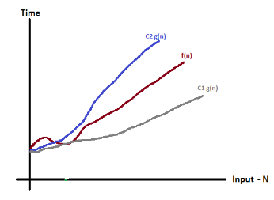
In above graph after a particular input value n₀, always C₁ g(n) is less than f(n) and C₂ g(n) is greater than f(n) which indicates the algorithm's average bound.
Example
Consider the following f(n) and g(n)...
f(n) = 3n + 2
g(n) = n
If we want to represent f(n) as Θ(g(n)) then it must satisfy C₁ g(n) <= f(n) <= C₂ g(n) for all values of C₁ > 0, C₂ > 0 and n₀>= 1
C₁ g(n) <= f(n) <= C₂ g(n)
⇒C₁ n <= 3n + 2 <= C₂ n
Above condition is always TRUE for all values of C₁ = 1, C₂ = 4 and n >= 2.
By using Big - Theta notation we can represent the time compexity as follows...
3n + 2 = Θ(n)

